**BREAST CANCER SURVIVOR?**



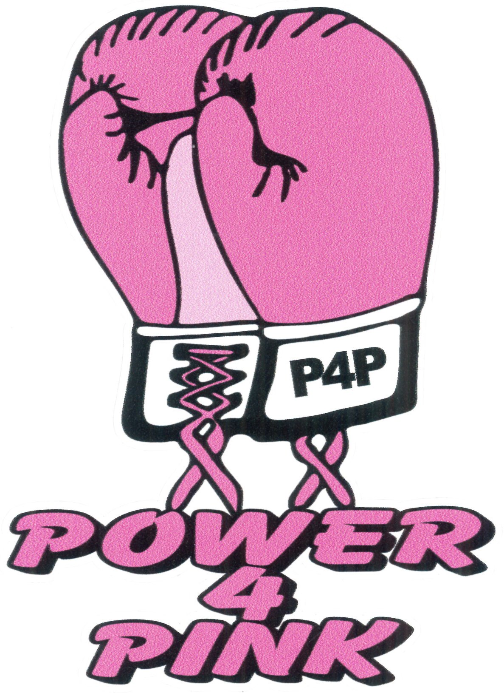

***Let’s Celebrate!***

***Come join us and enjoy an evening of Fun, Food and Fellowship***

***Fireworks following the game***

Hosted by:

**POWER 4 PINK INCORPORATED**

A 501(c)3 Charitable organization supporting breast cancer survivors in Lorain County

Location: Sprenger Stadium

**HOME OF THE LAKE ERIE CRUSHERS**

2009 Baseball Blvd, Avon

**FRIDAY**

**JUNE 15, 2018**

Crushers baseball game starts at 7:05 pm

***Each breast cancer Survivor will receive a complimentary ticket and picnic meal for themselves and one guest.***

*We need to plan for food and seats so please call to RSVP no later than June 8th to 440-654-8420. Please leave contact number, name and how many tickets are needed.*